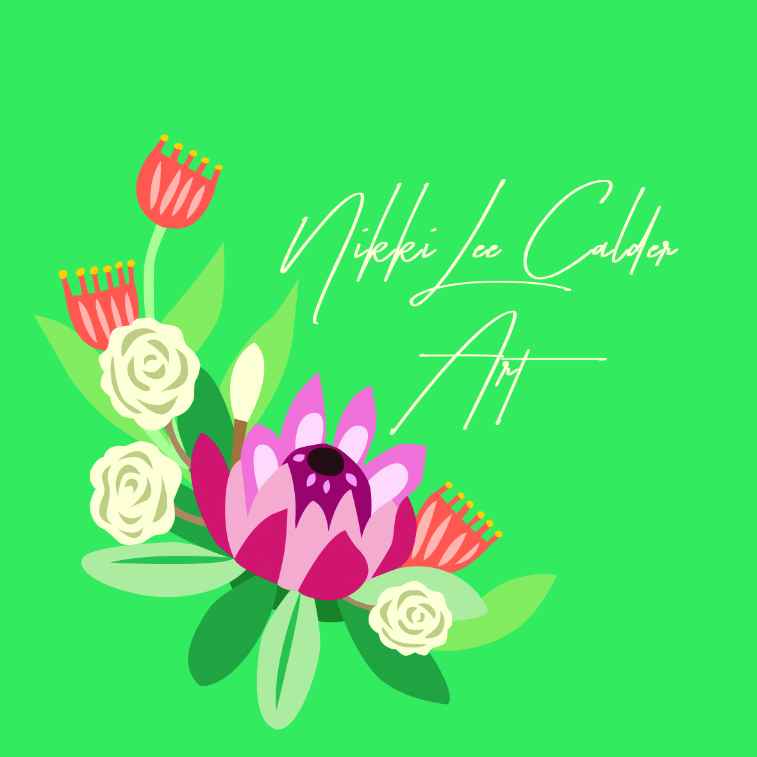

Price List

A drying fee of $100 will be invoiced to lock in your wedding date.

Buttonhole fit into shapes and sizes marked with\*

Add colour background - free

Add photo or invitation - $15

Laser engraved names & dates - $30

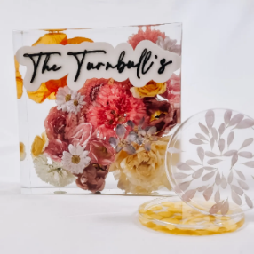

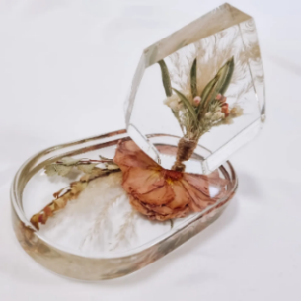

Andrea Jem

12x10cm - $180\* pictured

16x12cm - $275

Boho Arch

17x11cm - $275\*

15x13cm - $275\*pictured

22x17cm - $395 pictured

26x16cm - $475 pictured

25x22cm - $570

Square

15x15cm - $290\*

20x20cm - $420 pictured

25x25cm - $545

30x30cm - $780

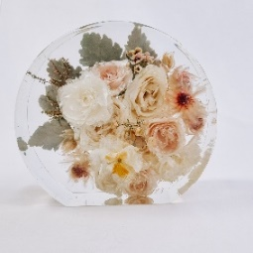

Ella

12cm - $250\*

17cm - $345 pictured

23cm - $490

28cm - $685

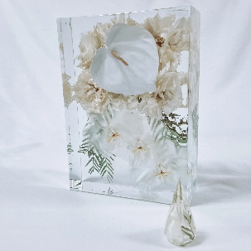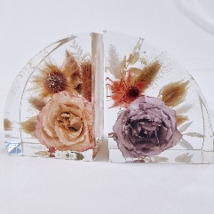

Book Ends

10x12cm set of 2 - $500\*left

17x25cm set of 2 - $750 right

Hexagon

12cm - $250\*

17cm - $345

20cm -$415

23cm - $490

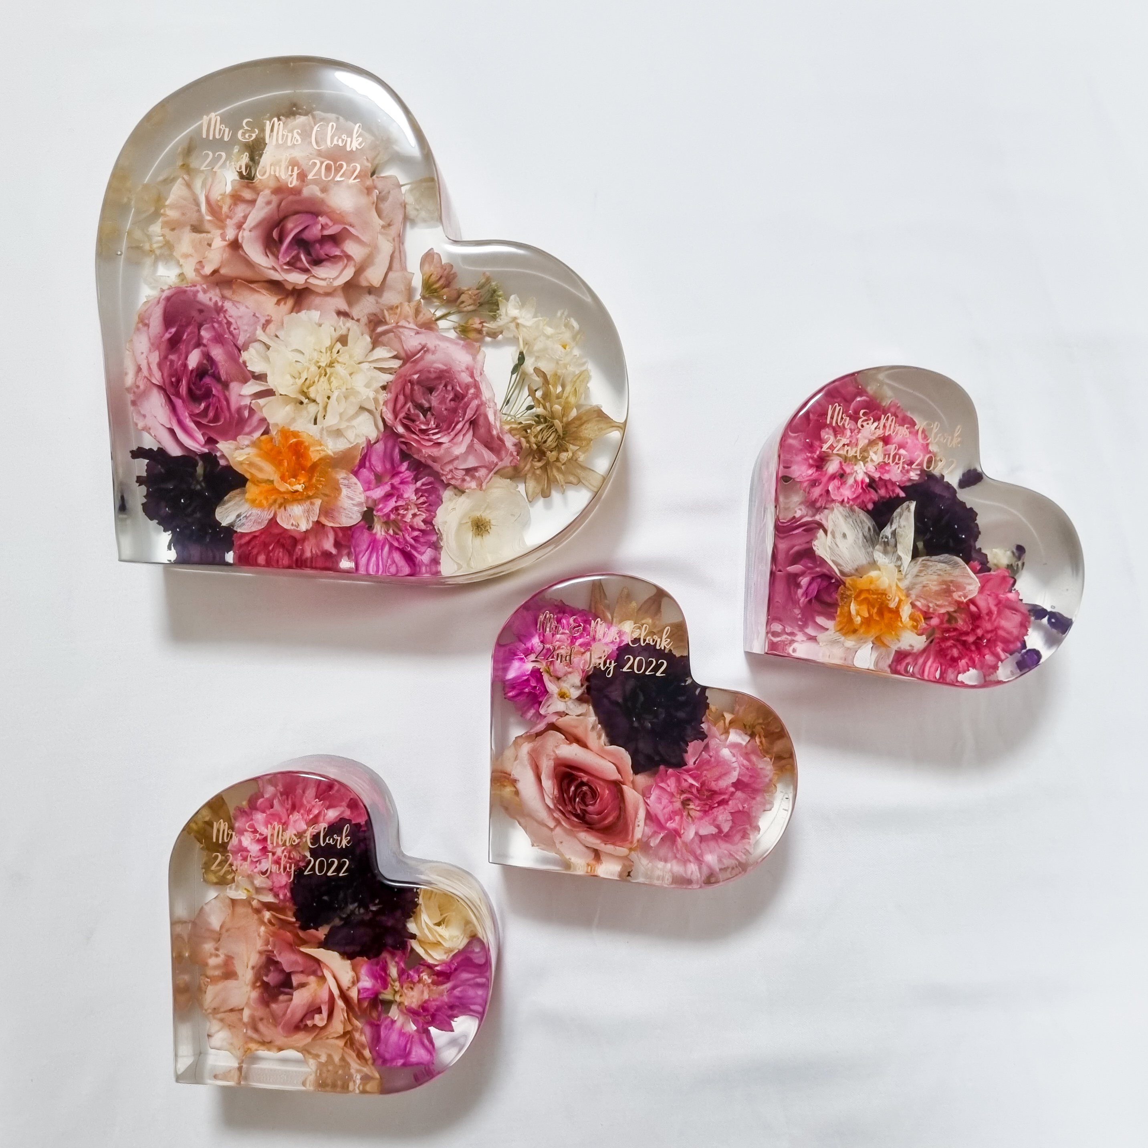28cm - $685 pictured

Heart

7cm - $120

13cm - $275\*pictured

25cm - $490 pictured

Letters

15cm $250 ea

23cm $490 ea

Rectangle

10x15cm - $250\*

15x20cm - $355

20x28cm - $520 pictured

22x35cm - $780

Display Board

30x30cm - $780

22x47cm - $855

29x39cm - $855

30x60cm - $945

30cm round - $780

40cm round - $995

60cm round- $1200

Frames

Flowers are pressed and set in resin then framed.

30x30cm - $380 pictured

30x45cm - $440

Candle holder

Sphere 12cm Wide $150

Cylinder 10cm Wide $80

Cylinder 4cm Wide set of 3 $90

Trinket dishes

9x9cm small round $40

9x18cm Pill shape $80

20cm Round 2cm deep $120

15cm Round 6cm deep $180

Coasters

Round, Hexagon, Square $20 each

Vase

Arch or Round $120

Wine stopper $30

Letter keyring $25

Heart Keyring $25

Gifts – small flowers only

10x2cm Bauble $60

Square $60

Arch $60

Hexagon $60

Circle $60

Ella $60

Letters $60

RingHolders

Lge diamond $90

Med diamond $70

Sml diamond $50

Med droplet $70

Lge droplet $90

